Educational Programs Institutional Effectiveness Plan and Report
Assessment Cycle (YYYY-YY) | 2020-2021 End-Year
Educational Program | Pioneer MBA
Program/Assessment Coordinator | Jacob I. Fait, PhD
Date (DD/MM/YYYY) | 6.8.2021

Program Mission Statement: To prepare leaders for business and civic engagement through an employer-focused curriculum.

Student Learning Outcomes
- Students will identify and integrate Common Professional Component (CPC) knowledge to solve business problems.(550,555)
- Students will Illustrate teamwork through completion of a team project.(540)
- Students will compose professional written and verbal communications.(535, 540)

Student Learning Outcomes for Educational Programs
I.  Student Learning Outcome | II.  Methods of Assessment (Short description of each assessment used to assess each outcome) | III.  Action Steps to be taken this cycle to Achieve the Outcome (should be drawn from the previous cycle’s use of results) | IV.  Assessment Results and Analysis of Results (include data and discuss the results). If the program is delivered through distance learning, all results and analysis must be provided for conventional delivery and distance learning delivery. | V.  Use of Results: Changes to be implemented next cycle.
Outcome 1:
Students will identify and integrate Common Professional Component (CPC) knowledge to solve business problems.(550, 555)

 | Objective 1: Students will validate CPC knowledge covered in the MBA program.(550)  Students complete the Peregrine Academics Graduate CPC exit exam in MBA550 which scores on a normalized percent correct method.  Our benchmark is to be within 5% points of Region 3 ACBSP schools.  Additionally, we strive to meet the Region 3 overall average score. | Discuss improvements in strategic planning meeting and annual Faculty in-service. Appoint an ad-hoc committee to further improve student learning.  Formed task force to investigate MBA curriculum and outcomes to ensure there is a match between curriculum and desired outcomes. Previously, the lowest scores on the CPC exam were in Finance. At the time of PY testing, we did not have a full-time terminally degreed faculty member to teach finance. We have since hired one and it is noticeable in student performance.  Another strategic change that was made this academic year was a change in text and design of the MBA accounting course. | 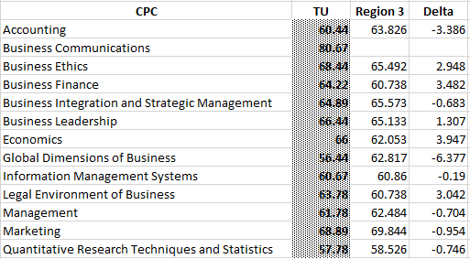  AY20/21 was essentially all conducted in a virtual environment and therefor there was no need/utility in delineating scores between F2F and online students. The two areas scoring the furthest under the Region 3 average were Accounting & Global Dimensions of Business coming in at 3.386 and 6.377 below the Region 3 average, respectively.  On average, our Tusculum MBA students scored above the region 3 average at 64.65 with the Region average being 64.09. This is the first time that TU has scored above the region 3 average.  45 students participated in this AY21/21 peregrine outbound assessment.  Here is trend data of our average test scores from the past four years:  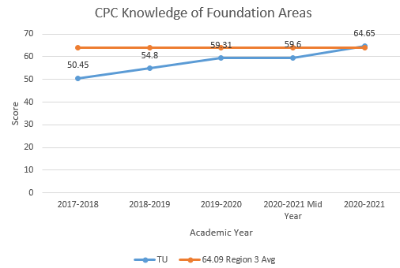 | Recommendations:  Continue to monitor and discuss improvements in strategic planning meeting and annual Faculty in-service. Particular attention and discussion should revolve around CPCs: Global Dimensions & Accounting.
 | Objective 2: Students will integrate CPC knowledge through application of a comprehensive business project.(555)  Students will author an original case study pertaining to their organization (employer, etc.). Using the combined knowledge of their MBA coursework, students are expected to analyze the organization, finding areas for improvement, connect those findings to their experience and discipline, explain how and communicate a plan for improvement based upon their findings. This assignment will be assessed utilizing the AACU Integrative Learning Value Rubric. | In the Summer 2020 term students were given the opportunity to present their comprehensive business projects in a pecha kucha format via zoom to practice pitching their plan to their employers. This will also allow the students to network with faculty, students, campus officials, alumni, and business advisory board members. Discussing their projects with diverse groups will allow them to spot weaknesses in their proposition and find areas to improve their proposal so that when it comes time to actually integrate this into their organization, they will have the best chance at success. | Students are expected to score at least 3 out of 4 on every rubric category. All students met the success criteria for each rubric category.  The rubric assessed student’s ability to make  - Connections to Experience  - Connections to the Discipline  - How this Translates to their Organization  - Integrated Communication  - Reflection and Self-Assessment  The average score for each category was:  Rubric Category SU 18 SU 19 SP20 SU 20  Connections to Experience 3.75 3.78 3.8 3.65  Connections to the Discipline 3.25 3.73 3.5 3.83  How this Translates to their Organization 3.25 3.86 3.9 3.85  Integrated Communication 3.25 3.92 3.8 3.83  Reflection and Self-Assessment 3.25 3.35 3.5 3.57  Students exceeded the goal for each rubric category. Students scored the lowest in the Reflection and Self-Assessment category of the rubric. This section assesses the student’s sense of self as a learner, building on prior experiences to respond to new and challenging contexts. However, the improvement in this category has improved each iteration of the course: 3.25, 3.35, 3.5, 3.57. Additionally, the trajectory is positive for all of the categories with the only real dip being in the connections to experience category.  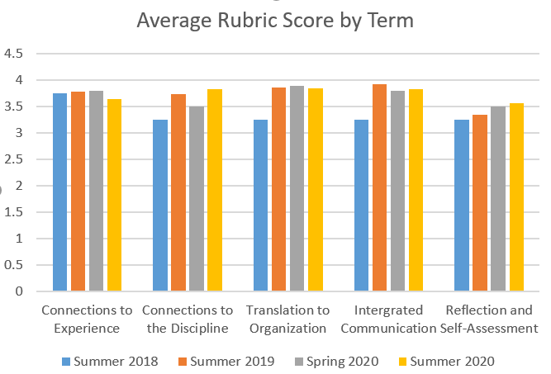 | Recommendations:  In summer 2021(currently) the class was divided into three sections(N=15 each) with three separate instructors. Previously this course was taught by one instructor with an N=45 or 50 total students. This intentionality in this transition was to better enable the faculty to spend more individual time with each student on their comprehensive project.  The recommendation is for the three faculty to meet, collaborate, reflect and share their experiences. Between the three Summer 2021 instructors there should be a plethora of areas for improvement going into Summer 2022.  In addition to the course enrollment restructuring, an additional component involving research and recommendations regarding international business/strategy policy was included for the overall project. Students are now expected to formulate a plan for international expansion into a non-native foreign market OR to use best practices and/or strategic modeling to expand their understanding of the strategic initiative they are investigating. Additional data collection is necessary before adjustments can be made to this facet of the project.
Outcome 2: Students will illustrate teamwork through completion of a team project.(540)

 | Objective 1: Students will evaluate teammates based upon performance at the half-way point of a term project.(540)  Students will be asked to evaluate each team member’s contribution to the team’s performance. List and rate all members of your team, including yourself, using the AACU Teamwork Value Rubric  The intention of this assessment is to allow the instructor to collect feedback from students early in the group formation process. Groups who have members who are underperforming according to their group’s ratings will be counseled by the instructor to improve on their various weaknesses in leadership, analysis, teamwork, creativity, and meeting deadlines. | Instructor will conference with students receiving an unacceptable evaluation from peers to intervene at the half-way point to assist students’ contributions to the group.  Teamwork rubrics are posted for all students to see in the Canvas site and requirements are spelled-out in the syllabus.  Instructor conferenced with students receiving an unacceptable evaluation from peers to intervene at the half-way point to assist students’ contributions to the group. | Students were divided into Learning Teams at random. They evaluated their team members and themselves using the AACU Team Value Rubric.  As the team was in its initial phase, we expected all scores to be “70%” or higher. Presented below are the results:  Average Teamwork Score by Term  Term Mid-point Final  Spring 2019 OL(33) 86.8 92.045  Fall 2019 OL(27) 96.729 97.19  Fall 2019 KNOX(11) 99.067 100  Fall 2019 Greene(19) 0 92  Spring 2020 OL(23) 95.067 95.429  Fall 2020 OL (20) 94.17 97.83  Fall 2020 KNOX (6) 97.5 98.5  Spring 2021 OL(11) 95.67 99.33  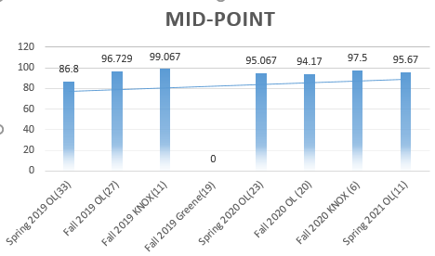  All students performed at or above the 70% range for the mid-point peer evaluation in AY20/21. | Recommendations:  For AY21/22 the instructors plan to conduct a weekly or bi-weekly meeting (beginning in week two) with each group as a course requirement with a grade attached. This added interaction is intended to further clarify course requirements, create team spirit, generate student engagement and strengthen the instructor-student relationship.
 | Objective 2: Students will evaluate teammates based upon performance at the ending point of a term project.(540)  Students will be asked to evaluate each team member’s contribution to the team’s performance. List and rate all members of your team, including yourself, using the AACU Teamwork Value Rubric | To better prepare students for this assessment, include the newly developed rubric in the Canvas site and create a learning activity in an early module to ensure students understand the peer-evaluation nature of this assessment. | As the team was in its concluding phase, we expected all scores to be “80%” or higher. Presented below are the results:  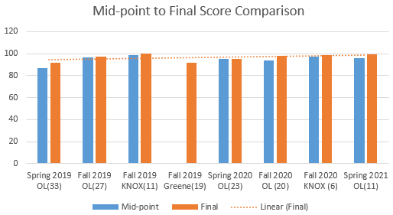  All students performed at or above the 80% range for the final peer evaluation in AY20/21. Additionally, as expected, scores in all AY20/21 improved from mid-point to the final peer evaluation. | Recommendation:  For AY21/22 the instructors plan to conduct a weekly or bi-weekly meeting (beginning in week two) with each group as a course requirement with a grade attached. This added interaction is intended to further clarify course requirements, create team spirit, generate student engagement and strengthen the instructor-student relationship.
Outcome 3: Students will compose professional written and verbal communications.(535, 540)
 | Objective 1: Students will compose articulate written communications.(535)  Students were asked to write a paper concerning the topic of managerial decision making. Students were assessed on their formal writing ability using the AACU Written Communication Value rubric. | In the latest iteration of written submissions for MBA 535 students were provided with a video of recommendations/expectations for course requirements. In this video, for the paper in particular, students were reminded of the need to execute the paper at a graduate level and generalized parameters and encouraged to ask questions. Beyond these instructions, students were strongly encouraged to consult with the instructor with regard to the development and execution of the written materials. Results from the last two iterations of data collection indicate that these interventions have had the intended results. These instructional elements will be continued and adjustments made as necessary. | 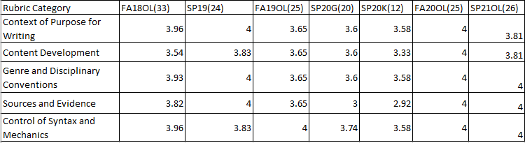  Twenty-five students participated in this assessment in the fall of 2020 and twenty-six students participated in the spring of 2021. Students were expected to score at least a 3 on each rubric category. All students met the success criteria. Average rubric scores are presented below:  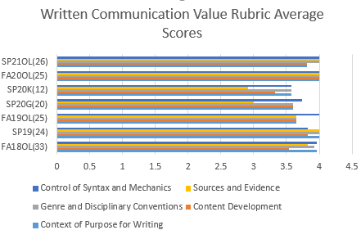 | Recommendations:  Continue with the instructional elements added during AY20/21 – Continue to monitor and make adjustments as necessary.
 | Objective 2: Students will compose articulate verbal communications.(540)  Students will be asked to present a student developed marketing plan. This assessment is measured using the AACU Oral Communication Value Rubric. Students are expected to score a 3 or higher on this assessment. | Based upon recommendation of our ACBSP Initial Accreditation review team, this objective was added to our assessment plan.  Instructor added additional detail for expectations for delivery of assessment in the course assignment and syllabus.  In AY20/21 the presentation style was changed to a 7-minute Pecha Kucha type presentation with loads of guidance given to students to ensure their success. | 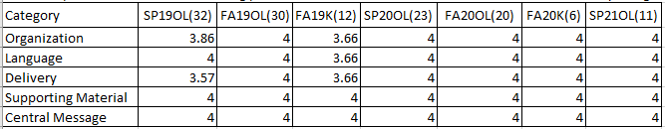  Six students participated in this assessment during Fall of 2020 and eleven during the spring of 2021. All students during AY20/21 scored a 4 on each rubric category. Average rubric scores are presented below:  The average score was well above the benchmark in each category.  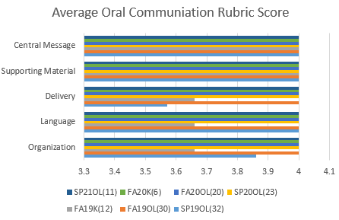 | Recommendations:  Consider alternative assessment measures as the group has exceeded 3’s in all iterations and had perfect scores of 4 in 5 out of 7 iterations.  As only one year of this data is the Pecha Kucha presentation style the recommendation is to stick with it but add zoom meetings to the course to meet with students and review their Pecha Kucha presentations in detail. The intent is to help with overall course satisfaction and quality.

