Educational Programs Institutional Effectiveness Plan and Report
Assessment Cycle (YYYY-YY) | 2020-21 Mid-year
Educational Program | Bachelor of Science in Business Administration
Program/Assessment Coordinator | Jacob I. Fait, PhD
Date (DD/MM/YYYY) | 6.4.2021

Program Mission Statement: Developing ethically, globally, and civically engaged business leaders.

Student Learning Outcomes
- Students will apply the foundational common professional components (CPC) to solve business problems.(449, 403)
- Students will identify and demonstrate knowledge and skills that indicate appropriate professional demeanor and career readiness.(325, 325)
- Students will exhibit commitment to civic engagement by applying business knowledge to a service project.(352, VITA)
- Students will demonstrate the ability to productively participate in group interactions and work effectively with others.(449, 305)

Student Learning Outcomes for Educational Programs
I.  Student Learning Outcome | II.  Methods of Assessment (Short description of each assessment used to assess each outcome) | III.  Action Steps to be taken this cycle to Achieve the Outcome (should be drawn from the previous cycle’s use of results) | IV.  Assessment Results and Analysis of Results (include data and discuss the results). If the program is delivered through distance learning, all results and analysis must be provided for conventional delivery and distance learning delivery. | V.  Use of Results: Changes to be implemented next cycle.
Outcome 1: Students will apply the foundational common professional components (CPC) to solve business problems.(449, 403)

 | Objective 1: Students will complete the Peregrine Academics Undergraduate CPC exam.(449)  Students complete the Peregrine Academics Undergraduate CPC exam in the BUSN 440 Policy and Strategy Course.  We benchmark against ACBSP Region 3 schools and expect our students to score within 5% of our benchmark on each category. Additionally, we set an overall goal of meeting the Region 3 average score. | The recommendation to hire a terminally degreed full-time finance faculty member has paid off and it evidenced by the vast improvement in finance scores. Action steps is to continue to review peregrine finance results with the finance faculty member to ensure continued improvement.  Formed task force to investigate undergraduate curriculum and outcomes to ensure there is a match between curriculum and desired outcomes. The task force shared their findings with the faculty and multiple curricular adjustments were made to ensure alignment. | 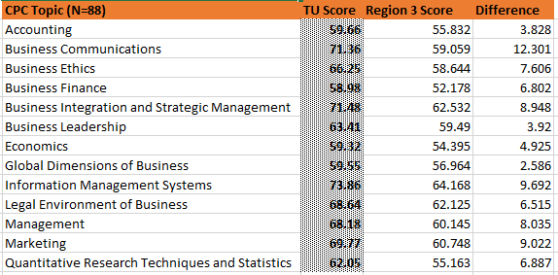  For the first time, TU students out-performed the Region 3 average on ALL CPC topics!  Business Communications was the CPC area with the greatest performance over the Region 3 average, 12.30. Both Accounting and Business Leadership were the two CPC areas with the smallest score in excess of the Region 3 average with 3.83 & 3.92 respectively.  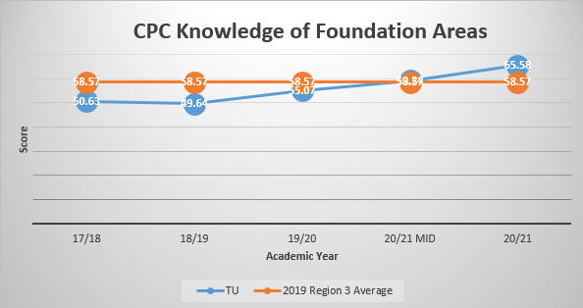 | Recommendations:  To share this data with the math department that teaches out MATH140 statistics class that is a core requirement of the BSBA program. Additionally, it is recommended that the CoB consider teaching this class in-house.  Additionally, the previously formed taskforce should review the new data for changes and anomalies.
 | Objective 2: Students will explore ethical dimensions and create a code of conduct for an organization.(403)  Students will be required to create a code of conduct for an existing organization. The assignment will be assessed via the Code of Conduct Rubric. Students are expected to score in the Accomplished/Exemplary ranges for each rubric category(i.e. 80% or greater). | Address the need for students to make broader connections/implications to the organization that will allow them to draw thoughtful conclusions and awareness of the future implications of ethical issues. Develop an in-class discussion that will focus on ethical decision making within an organization. | 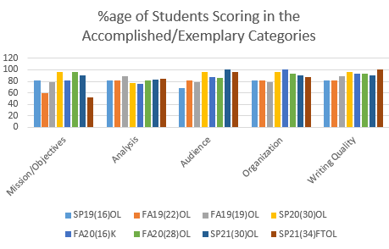  In general, there is a positive trend in each of the 5 rubric categories. Continue to monitor. | Recommendations:  Continue to address the need for students to make broader connections/implications to the organization that will allow them to draw thoughtful conclusions and awareness of the future implications of ethical issues. Develop an in-class discussion that will focus on ethical decision making within an organization.
Outcome 2: Students will identify and demonstrate knowledge and skills that indicate appropriate professional demeanor and career readiness.(325)
 | Objective 1: Students will organize relevant personal career related experience and abilities into a professional business resume.(325)  This is assessed via resume rubric.  Students are asked to organize relevant career experience and abilities into a professional business resume.  The rubric assesses students based on ratings of 5-point Likert scale, with 5 being the top score. Students are expected to score in the at least 3 for each rubric category. | Provide in-class examples of how to present experience (educational or employment) on a resume. Give examples on what spent leading a project additional sections of a resume could look like. This will include leadership awards, times, etc. | 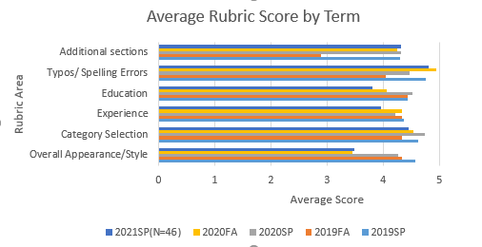  Students are expected to score in the “above average” ranking for each rubric category(ie. 3 or greater). Students met this in every rubric category in SP21 and FA20 and in each term prior with the exception of 2019 FA.  *note, this year the resume assignment transitioned from being embedded in BUSN 226 (Accounting) and into BUSN325 – Professional Communications. | Recommendations:
 | Objective 2: Students will identify appropriate strategies for business interviews and interpersonal communication.(325)  This assessment was a 20-question multiple choice quiz in the BUSN 226 course until Fall of 2020 when it was transitioned to a 10-question quiz( week 4) in the BUSN 325 course. This assessment was an internal, direct, and formative assessment that assessed the student’s ability to identify appropriate behaviors for interviewing.  Students were expected to score at least 80% in each category. | The instructor will continue to fine-tune the quiz questions to ensure that they are relevant to interpersonal communications and career readiness. | 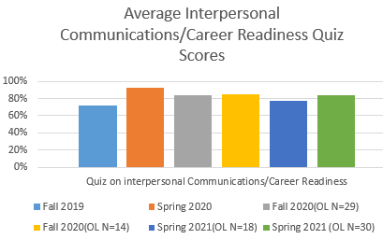  Students scored relatively the same each term with scores ranging from 72% to 92% in Fall 2019 and Spring 2020, respectively. Both online Fall 2020 classes were in the 84-85% range, exceeding the goal of 80%. The Spring classes were 77% and 84%, respectively with the first dipping below the 80% goal. (Note: lower N of 18) | Recommendations:  This assessment moved from BUSN 226 to BUSN 325 – Professional Communications which is a more appropriately class for this assessment. Recommendation is to monitor this assessment to ensure that we are capturing it adequately. An additional recommendation is to review data and perhaps report the %age of the class scoring over 80% rather than an average score.
Outcome 3: Students will exhibit a commitment to civic engagement by applying business knowledge to a service project. (352, VITA)
 | Objective 1: Students will present on financial literacy to Tusculum Experience students. (BUSN 352) | This year students gave three presentations to first- and second-year students in the OREN-105 “Tusculum Experience” class as part of the BUSN 352 Business Service-Learning Practicum. In prior years students were only required to complete one or two presentations.  *Some of these presentations had to be adjusted into synchronous and asynchronous recorded presentations due to COVID-19. | Students were assessed using a presentation rubric. The rubric is a 12-point Likert scale with 12 being the high score. Note: Due to COVID-19 changes the OL section in the late term completed an alternative assignment.  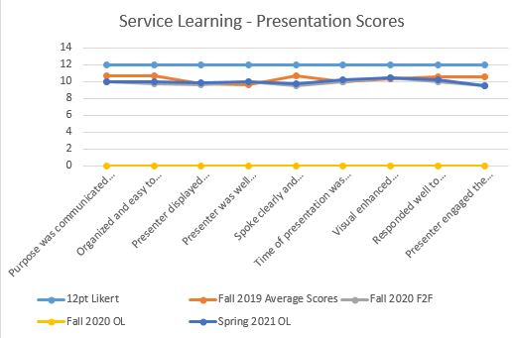
 | Objective 2: Students will apply accounting and tax knowledge to assist additional community members in filing an accepted federal income tax return. (VITA) | Due to COVID-19 restrictions the Volunteer Income Tax Assistance class had set a goal of 450 tax returns. They have pared back the class to just 2 sites where in the past it had 4+ and have changed their process to limit exposure for both students and community members. They exceeded their goal by 45 returns! | 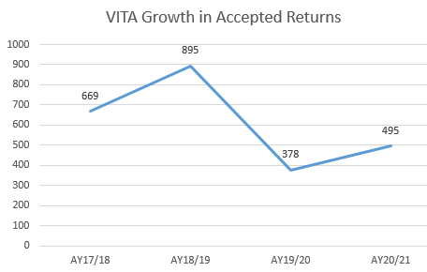
Outcome 4:
Students will demonstrate the ability to productively participate in group interactions and work effectively with others. (449, 305)
 | Objective 1: Students will work together to complete a business strategy simulation (BUSN 449) | Students compete in a strategy simulation as a team, and rank their teamwork via a multiple choice survey The survey asks a series of 12 questions, worth varying point values, for a total score of 100%. Students are expected to score at least 80%.  For Fall 2020 students undertook this activity twice, at the beginning of the simulation and towards the end of the simulation. The intent was to make students aware of the two ranking events and correct any miss-aligned behavior. For Fall 2020 the two rankings were averaged for each student.  Additionally, the instructor worked to have additional dialogue with students to convey the value of their contribution and how each element affects overall team performance. | 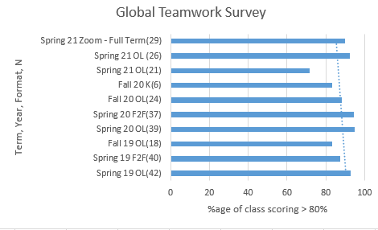  In Fall of 2020 both the OL and in-person class had greater than 80% of the class scoring over 80% on the teamwork rubric. In Spring of 2021, one of the 7-week OL classes fell below the goal with only 71.43% of the class scoring greater than 80%
 | Objective 2: Students will complete surveys ranking teammates participation in the Marketing Plan Project (BUSN 305)  Students prepare and present a marketing plan as a group. Then the students are asked to complete a survey ranking their teammates participation. The survey is adapted from the AACU Value Rubric.  Students are expected to score above a 3.5 on all rubric areas. | Instructor started having conferences with each team to mediate any team conflict before the evaluation period. | 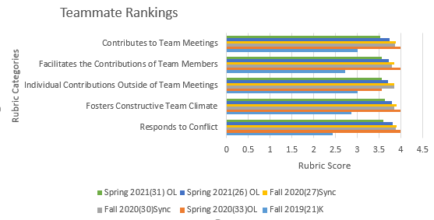  Students met the 3.5 goal on all 5 of the rubric categories in Fall of 2020 and in the spring of 2021. The lowest score noted is a 3.52 in the ‘Contributes to Team Meetings’ category. Further planning activities may be able to have a positive impact upon this rubric category.  *Note: Due to COVID-19 Fall 2020 BUSN-305-E500A & BUSN-305-L500 completed an alternative assignment and are not represented in this dataset. | Recommendations: Continue to monitor results of this assessment. Two things to consider as this assessment spans longitudinally over another academic year: 1.) Consider increasing the expectation threshold if students continue to exceed it for another academic year. 2.) Consider a Pre & Post ranking of teammates to see if further dialogue has an impact.

The Common Professional Components (CPC) of business include 12 topics essential to business education: Accounting, Ethics, Finance, Business Integration and Strategic Management, Leadership, Economics, International Business, Management Information Systems, Business Law, Management, Marketing, and Quantitative Research/ Statistics.

